Fitness World Style Guide

# Project Mission:

* + We aim to provide people one step destination for all their fitness needs such as buying gym equipment’s, locating nearby gyms, getting diet chart, buying healthy food products, etc.

# Target Audience:

* + Young People, Working Professional.

# Logo;

For Now we are working on our logo but this is our first logo

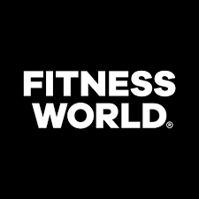

# Colors:

# rgb(161, 161, 7)

# #222b3d

# #343a40

# white

# Font:

* + Cambria, Cochin, Georgia, Times, "Times New Roman", serif
  + Lucida Sans", "Lucida Sans Regular", "Lucida Grande", "Lucida Sans Unicode", Geneva, Verdana, sans-serif